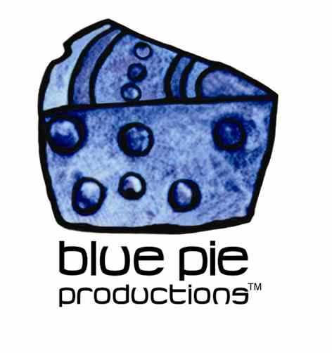
PRESS RELEASE - EFFECTIVE IMMEDIATELY – 11 JANUARY 2013

THE OBJEX TOURING FOR 2013! LOCK UP YOUR KIDS AND YOUR GOATS

Blue Pie's Alternative Punk ‘n’ Roll band The Objex is performing a show at the ‘Double Down Saloon’ in Las Vegas on January 18th as part of the AVN Party from 10 pm onwards.
The four piece group consisting of Felony Melony on vocals, Jim Nasty on guitar, Chlie on drums and Ivan on bass were originally formed in 2006 and are heavily influenced by David Bowie, Tina Turner, Green Day, and Chuck Berry. Their debut album in 2007 ‘Attack of the Objex’ resulted in a series of shows and high profile appearances. They became quickly noticed for their outlandish and aggressive style and their music was included in many independent films, TV shows and magazines.
In 2010, they won the Vegas Rocks Award for Best Punk Rock Band and were later nominated for a Hollywood Music Award for best alternative song in 2011. They have recently recorded their latest EP and are preparing to release it within the next month.
With the help of ‘Self Made Records’ in the UK, the band will be announcing dates for an upcoming tour for the 2nd QTR 2013. The band is scorching hot and we absolutely love them with all our punk rock passion we can muster.
To check out more of The Objex and their crazy punk rocking antics, be sure to head to their official YouTube page! www.youtube.com/user/Objexlv

********************************************************************************
ABOUT THE OBJEX:
The Objex were formed in January of 2006 in Las Vegas, USA. Under the vicious, sexy and soulful voice of Felony Melony, aka the ‘Punk Rock Tina Turner’, The Objex have won over audiences and received critical acclaim from their peers all over the world!
Joined on the stage by Aly 2x (Aly two times) on bass, Jim Nasty on guitars and a new addition from South America, Chile on drums, The Objex have been bringing back the hard old school punk and thrashing it into the youth of today! Soon after formation, they released their first record, ‘Attack of The Objex’ in January of 2007, and are currently putting the finishing touches on their sophomore album.
********************************************************************************
*******************************************************************************
ABOUT BLUE PIE THE RECORD LABEL:
www.bluepierecords.com
Blue Pie Records is one of the world’s leading independent record Labels and publishing houses. Blue Pie Records has a wide range of alliance-partnerships which it calls upon to create distribution, production, marketing and promotional systems for our artists, labels and global content partners.

Blue Pie's priority artists include Sydonia, Burning the Day, Jack Derwin, The Benjamin Hyatt Band, Terry Oldfield, Phil Manzanera, Johnny Bennett, Suzanna Lubrano, The Objex, Gordon Waller, Dave Evans, Dale Bozzio, and Jessy Tomsko along with labels like ConcertHouse Music, TRAX Records, Mahoning Valley Records, Idyllium Muisc, Sugo Music, Deluxe Records, Reality Entertainment, and PLG Music Group to name a few. Our live concert and video clip library continues to expand and includes live albums, video clips, and video concerts from artists including, Chicago, The Cars, Tiesto, Steve Aoki and Dave Evans to name a few.

Blue Pie's roster of artists continues to gain worldwide recognition with chart success in the USA, Canada, Europe and Australia. Blue Pie is continually developing new markets for our artists, labels, content partners to connect and reach new consumers and fans for their music. The Blue Pie license team has placed over 2000 film, TV, cable show and advertising license sales over the past 3 years alone. The label provides transparent reporting and digital asset management services through its partner Blue Pie Data www.bluepiedata.com

Blue Pie has developed exclusive digital content supply agreements with many companies including: DJ Central TV, Blue Vault Digital, Magic Blue Creative and their partners. The future is bright and we are wearing shades with our expansion into ASIA, North America and Latin America from 2013 onwards. For more information on Blue Pie please visit www.bluepie.com.au

Blue Pie’s label roster includes:
- Electrik Blue Records USA
- Rock Forever Records
- Reality Entertainment (For Australian and New Zealand)
- Globalev World Music
- Deluxe Records
- Pride Music
- Concerthouse Music
- Self Made Records UK
- Media World
- UnCanny Inc
- Subsonic Records
- + Over 200 others. See our website for details.

Search on 'blue pie' in Google for more information.
**END***

Press and Media Contact:

Press and Media Manager
Blue Pie
Unit 20 No 112 McEvoy Street
Alexandria NSW 2015
P: + 61 2 9310 0155
F: + 61 2 9310 0166
E: pr@bluepie.com.au
W: www.bluepierecords.com

************************************************************************

