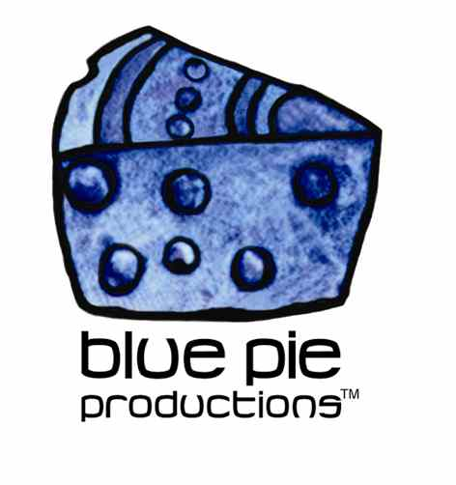
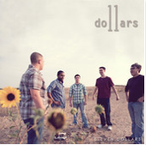

PRESS RELEASE - EFFECTIVE IMMEDIATELY – 26/06/12

Social Boom for Eleven Dollars

A social torpedo has exploded onto fellow band Eleven Dollars, as their weekly total of likes, fans, and posts about the band, reached a whooping 27,683 on their Facebook page.
Our marketing team has worked hard to promote the band on Facebook and other social media avenues, and it seems to have had quite the domino effect. The power of Facebook has now created an exciting new fan base for the boys.
Eleven Dollars truly have musical skill with a sound that leaves you wanting more from them. This is very good news for the boys, as from this moment on, their ability to expand their number of fans and supporters, can be successfully achieved through social media tools and with the help of our marketing team at Blue Pie Records.
We are excited to see them move their way up the musical ladder in the competitive music industry and we want to congratulate them on their success and we wish to continue helping and supporting them as much as we can in the near future.
****************************************************************************
ABOUT ELEVEN DOLLARS:

In 2003, longtime friends Chris Mills and Cris Womack shared an apartment in Lewisville, TX. Like so many other musicians, the two starting playing and writing songs for fun. Their creativity turned into serious business as they began playing venues in the Denton area.
Trying to think of a band name, Mills and Womack ended up choosing Eleven Dollars, "since that's all we thought we would make." Of course, they underestimated themselves and, in 2005, they picked up the lead guitar skills of Brandon Deem and bass player, Doug Benscoter.
The four-piece band played venues and festivals for another two years before bringing in the final piece to the puzzle: musician, Steve Hughes. With the newly crafted band finally in place, Eleven Dollars has recorded a popular EP, "Missing Pieces," and an LP, "Studio B," released in 2010. In addition to their albums, the music of Eleven Dollars has been featured in the independent films, "After School Special" ("Laurensong") and "In Eternity" ("You," "Goodnight and Goodbye"). With multiple tours lined up for the summer and the talents of multiple booking agents, Eleven Dollars is geared toward becoming the next big music attraction
For more information on the band you can visit the bands website at www.elevendollars.net
****************************************************************************************
ABOUT BLUE PIE THE RECORD LABEL:

www.bluepierecords.com

Blue Pie, the record label, is one of Australia’s leading independent labels. Founded in the early 90’s by Damien Reilly, the label has a wide and diverse range of alliances, global partnerships and proprietary technology that it makes available to all the companies artists, labels and content partners. These relationships combined with Blue Pie Productions, technology, systems and infrastructure allows Blue Pie’s artists and labels to reach new and exciting fan bases and markets globally, increase their profits and most of drive and develop new revenues.

Blue Pie is proud to represent over 200 labels and over 3000 artists worldwide.

Blue Pie's artists include:
Dave Evans (AC/DC), Phil Manzanera (Roxy Music), Peter Head, Headband, Tiny Tim, Sabrina Fustaire, Funky P, Suzanna Lubrano, Benjamin Hyatt, Tony Hatch (Grammy Winner), Serge Ermoll (ARIA WINNER), Dave Sharp, Dale Bozzio, Tommy Tutone, Peter & Gordon, Gordon Chambers (Grammy Winner), Barry Crocker & Janice Marie (Grammy Winner)

Blue Pie’s label roster includes:
- Electrik Blue Records USA (Blue Pie Label)
- Blue Pie USA (Blue Pie Label)
- Prime Records USA
- Rock Forever Records
- Reality Entertainment (For Australian and New Zealand)
- Globalev World Music
- Deluxe Records (Michael Browning’s Label)
- Pride Music
- Concerthouse Music
- Holliday Entertainment
- Artist Development Network
- AIN Distributions and Music
- Sharkarts.
- Subsonic Records
- + Over 200 others. See our website for details.

Search on 'blue pie' in Google for more information.

