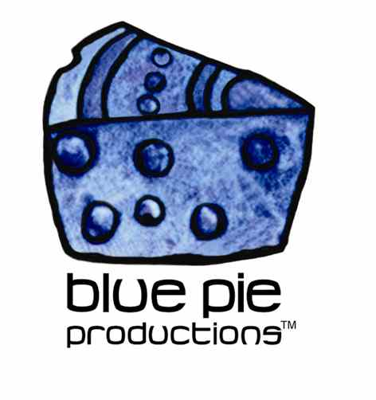


PRESS RELEASE - EFFECTIVE IMMEDIATELY – 25TH JUNE 2012
DOCTOR AIYK’S “BROWN SUGAR” CLIP IS A NUMBER ONE HIT!

Doctor Aiyk, aka FloSmith’s single, “Brown Sugar” has endured a number one position on the MTV Base and the African Music Charts for over ten weeks.

Blue Pie Records released the hit track, known for its gentle melody and smooth vocals, into the airwaves in 2010. Since then, “Brown Sugar” has slowly built a great deal of momentum, exploding on video playlists, throughout the year of 2011.

Doctor Aiyk is an “experimental” fusion artiste, a talented songwriter, soulful singer, actor and a gifted acoustic guitarist based in Lagos, Nigeria. His unique style has captured the melodious riffs of West African music, in addition to having drawn influences from the lyrical genius Bob Marley, while fusing tribal and ethnic riffs and rhythms together with contemporary vocals and production techniques.

The song has now been added to the Blue Pie Film and TV Production Music Library, in addition to becoming a featured track in a number of promotional clips for various food and drink companies within Africa.

You can purchase “Brown Sugar” on iTunes:
www.itunes.apple.com/au/album/brown-sugar/id383544859

View the number one video for “Brown Sugar” on YouTube here: www.youtube.com/watch?v=Tktfar7nk2c&feature=plcp
********************************************************************************ABOUT BLUE PIE THE RECORD LABEL:
www.bluepierecords.com
Blue Pie, the record label, is one of Australia’s leading independent labels. Founded in the early 90’s by Damien Reilly, the label has a wide and diverse range of alliances, global partnerships and proprietary technology that it makes available to all the companies artists, labels and content partners. These relationships combined with Blue Pie Productions, technology, systems and infrastructure allows Blue Pie’s artists and labels to reach new and exciting fan bases and markets globally, increase their profits and most of drive and develop new revenues.

Blue Pie is proud to represent over 200 labels and over 3000 artists worldwide.

Blue Pie's artists include:
Dave Evans (AC/DC), Phil Manzanera (Roxy Music), Peter Head, Headband, Tiny Tim, Sabrina Fustaire, Funky P, Suzanna Lubrano, Benjamin Hyatt, Tony Hatch (Grammy Winner), Serge Ermoll (ARIA WINNER), Dave Sharp, Dale Bozzio, Tommy Tutone, Peter & Gordon, Gordon Chambers (Grammy Winner), Barry Crocker & Janice Marie (Grammy Winner)

Blue Pie’s label roster includes:
- Electrik Blue Records USA (Blue Pie Label)
- Blue Pie USA (Blue Pie Label)
- Prime Records USA
- Rock Forever Records
- Reality Entertainment (For Australian and New Zealand)
- Globalev World Music
- Deluxe Records (Michael Browning’s Label)
- Pride Music
- Concerthouse Music
- Holliday Entertainment
- Artist Development Network
- AIN Distributions and Music
- Sharkarts.
- Subsonic Records
- + Over 200 others. See our website for details.

Search on 'blue pie' in Google for more information.
**END***

********************************************************************************

