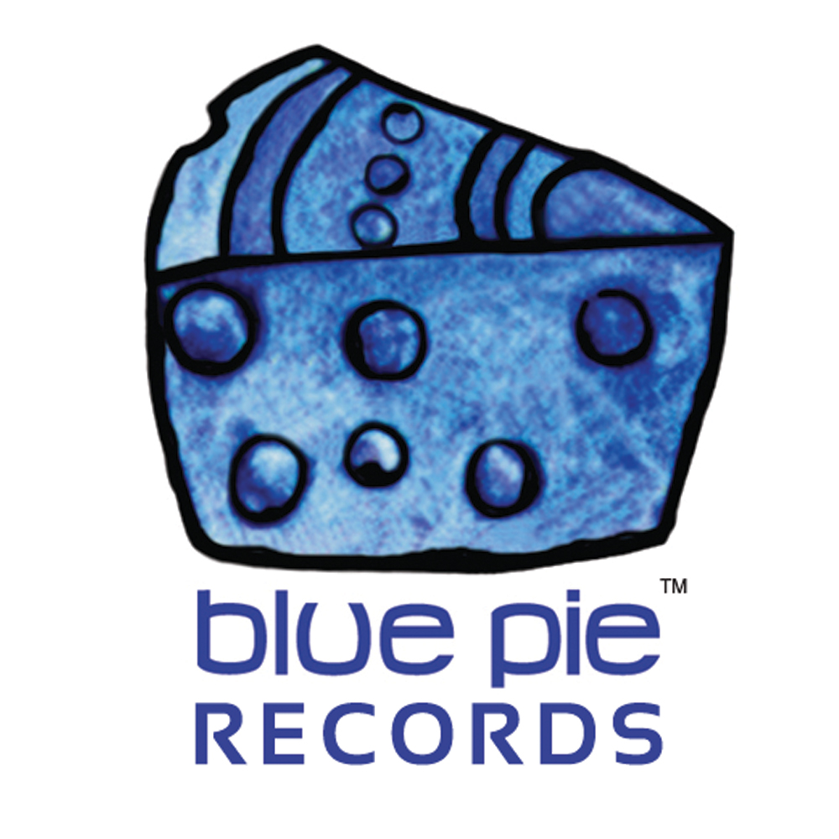

PRESS RELEASE - EFFECTIVE IMMEDIATELY – 22nd May 2012
Brigitte Stolk releases her new single “Everyday”.

“Everyday” is the new track from Brigitte Stolk, which will leave listeners minds reeling in wonder. With her eccentric sound and eclectic style, Stolk may just be the funk and soul that the world needs to hear. She’s been compared to Janet Jackson and Aalyiah and many other powerful songstresses. Her soulful voice has gained her praise from audiences around the world for years and now it’s time for Brigitte to take the main stage.

In 2002, her first single “I’m Sorry”, was released, under the moniker “SWEET B”. She followed this with a full-time length album release “Solid’air” (2004), which was released with singles “Come 2 Mee” (2006) and “IT’S XMAS” (2008). In 2009 “Come 2 Mee” was chosen as the original soundtrack by French film producer Alain Zirah for his series “The Kat Ladies”.

Brigitte lyrically draws on her life experiences to tell stories throughout her music. She is forever constantly referencing her experiences in culture and the affirmation of her studies in Jazz, singing in gospel choirs and performing in hip-hop groups.

“Everyday” is a prime example of what Stolk’s album “Solid’air” represents, true old school funk along with a voice that will bring the house down.

You can download “Everyday” now. To find out more information on Brigitte Stolk please follow the following links to her social media websites:

Facebook: www.facebook.com/brigitte.stolk.5/info
Myspace: www.myspace.com/brigittestolkmusic/music/songs/enough-83156784
***************************************************************************

ABOUT BLUE PIE THE RECORD LABEL:
www.bluepierecords.com
Blue Pie, the record label, is one of Australia’s leading independent labels. Founded in the early 90’s by Damien Reilly, the label has a wide and diverse range of alliances, global partnerships and proprietary technology that it makes available to all the companies artists, labels and content partners. Blue Pie is proud to represent over 200 labels and over 2000 artists worldwide.
Blue Pie's artists include: Dave Evans (AC/DC), Phil Manzanera (Roxy Music), Peter Head, Headband, Tiny Tim, Sabrina Fustaire, Funky P, Suzanna Lubrano, Benjamin Hyatt, Tony Hatch (Grammy Winner), Serge Ermoll (ARIA WINNER), Dave Sharp, Dale Bozzio, Tommy Tutone, Peter & Gordon, Gordon Chambers (Grammy Winner), Barry Crocker & Janice Marie (Grammy Winner) Search on 'blue pie' in Google for more information.
************************************************************************
Contact Details:

Blue Pie Records USA LLC
Press and Media Manager
Unit 20 No 112 McEvoy Street
Alexandria NSW 2015
P: + 61 2 9310 0155
F: + 61 2 9310 0166
E: media@bluepie.com.au
W: www.bluepierecords.com
************************************************************************

***END***

