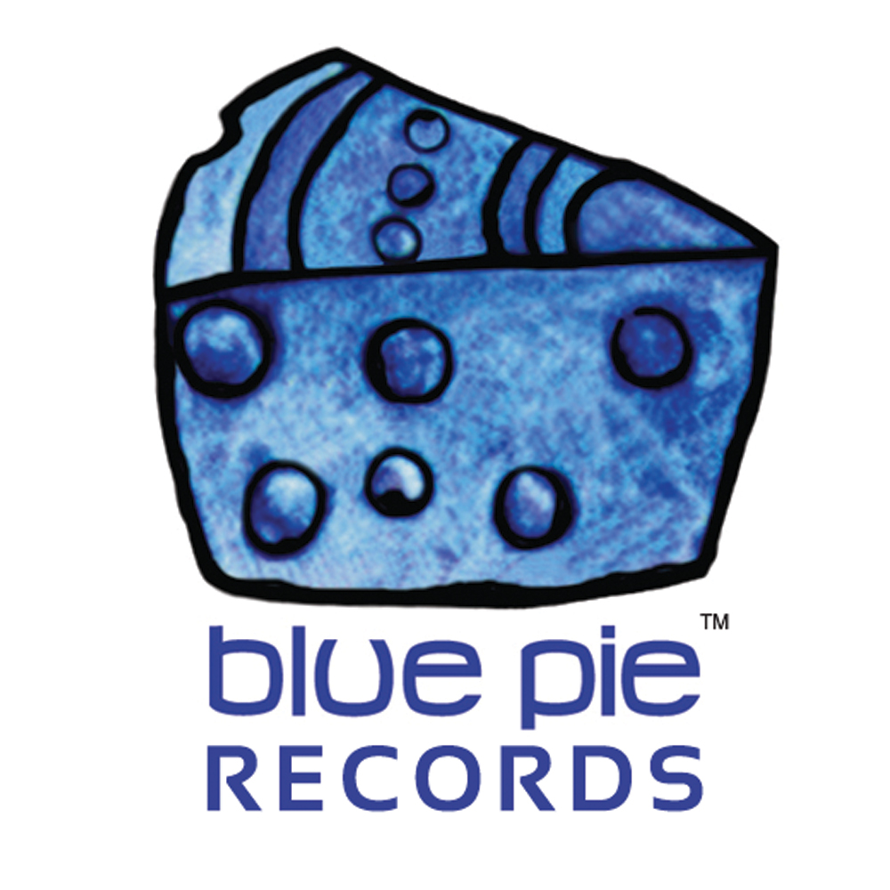

PRESS RELEASE - EFFECTIVE IMMEDIATELY – 29th JUNE 2012

BLKRAW BECOMES FINALIST FOR HOME TURF RADIO

Blue Pie’s Hip-Hop artist BLKRAW has become a finalist for Home Turf Radio! He will compete against two other artists to win the most votes so his song can be played on Hip-Hop and RNB radio station, 106KML.

At the moment, BLK is in the lead, sitting at about 50 votes, but we encourage fans to show their support and make sure he stays on top.

To vote, please visit the KMEL website and choose “Striving Artist” at: www.kmel.com/pages/hometurf.html - it only takes a couple of seconds of your time!

Voting will close on Sunday, 1st July.

California born BLKRAW is one artist that won’t be put in a box. He is known for his unique smooth style, with awesome vocals, great lyrics and head bopping beats, taking listeners on a musical journey.

To listen to his music, visit iTunes: http://itunes.apple.com/au/album/alter-ego-feat.-big-mayne/id521495031

Also check out these websites for more information:
www.blkraw.net
www.facebook.com/blkraw
www.twitter.com/blkraw
www.reverbnation.com/blkraw

************************************************************************
ABOUT BLUE PIE THE RECORD LABEL:
www.bluepierecords.com
Blue Pie, the record label, is one of Australia’s leading independent labels. Founded in the early 90’s by Damien Reilly, the label has a wide and diverse range of alliances, global partnerships and proprietary technology that it makes available to all the companies artists, labels and content partners. Blue Pie is proud to represent over 200 labels and over 2000 artists worldwide.
Blue Pie's artists include: Dave Evans (AC/DC), Phil Manzanera (Roxy Music), Peter Head, Headband, Tiny Tim, Sabrina Fustaire, Funky P, Suzanna Lubrano, Benjamin Hyatt, Tony Hatch (Grammy Winner), Serge Ermoll (ARIA WINNER), Dave Sharp, Dale Bozzio, Tommy Tutone, Peter & Gordon, Gordon Chambers (Grammy Winner), Barry Crocker & Janice Marie (Grammy Winner) Search on 'blue pie' in Google for more information.
************************************************************************
Contact Details:

Blue Pie Records USA LLC
Press and Media Manager
Unit 20 No 112 McEvoy Street
Alexandria NSW 2015
P: + 61 2 9310 0155
F: + 61 2 9310 0166
E: media@bluepie.com.au
W: www.bluepierecords.com

************************************************************************

***END***

