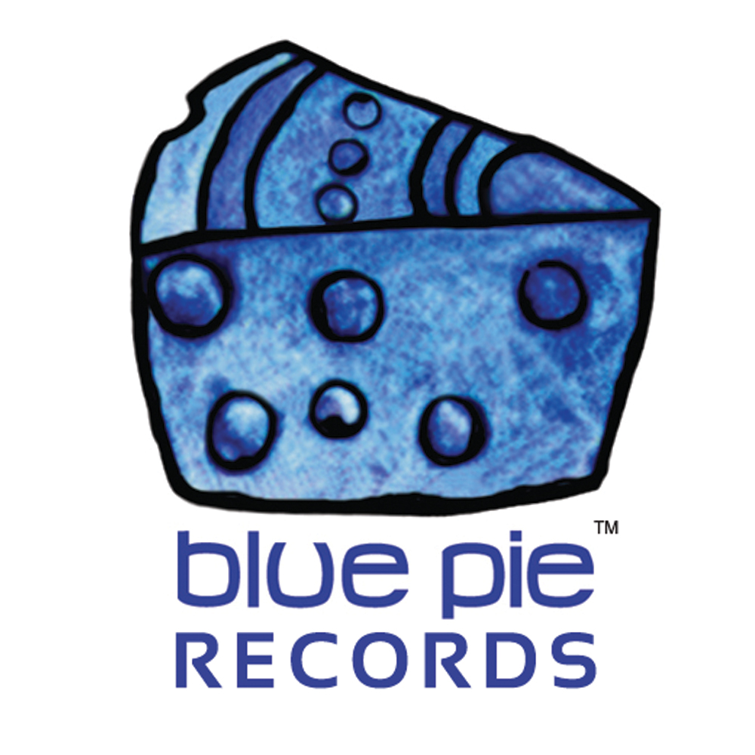


PRESS RELEASE - EFFECTIVE IMMEDIATELY – 25th May 2012

BLKRAW releases his new hip-hop groove single “Nobody Like You”

BLKRAW’s new track hits the sound waves with “Nobody Like You”. The song, distributed by Blue Pie Records, is not only an incredible track to keep you dancing with its techno groove, but it also retains heartfelt lyrics such as “I be around the world I be around the world I be around the world but I never met nobody like you girl”.

“Nobody Like You” is a single taken from BLKRAW’s recent release “Alter Ego”. With other successful singles such as “Sexy Girl” and “Like This” having already been released from the album, “Nobody Like You” is expected on the track listings for all of the hottest clubs.

Don’t miss out on checking BLKRAW’s new track! You can listen on various social networking sites such as:
MySpace: www.myspace.com/blkraw
Facebook: www.facebook.com/blkraw

************************************************************************

ABOUT BLKRAW

BLKRAW is Unique, one of a kind, energetic & the hardest working unsigned artist out of El Centro. You can’t put him in a box. He has a flow that is universal to all, not just one group. BLKRAW takes his listeners on a musical journey that has an all around hip-hop and R&B feel. His hip-hop style is smooth, great vocals, great lyrics and great rhythms.
Growing up with music being the face of his household. He has always been surrounded by music. If it was not his mother playing her old-school jams, (Smokey Robinson, Temptations) it was his big brother singing, Jodeci or writing and giving a talent show. In the late 80′s early 90′s, after his brother’s death, he started to take his music career serious. In 2003 he began to record songs and has not looked back since.
BLKRAW gets most of his inspiration from music itself. Artist such as LL Cool J, Nelly, Big Daddy Kane, Kool Mo Dee, Heavy D, 2 Pac and B.I.G. His work ethic is what sets him apart from the others. His self-identity, what he lacks in one area he makes up for in the next

************************************************************************
ABOUT BLUE PIE THE RECORD LABEL:
www.bluepierecords.com
Blue Pie, the record label, is one of Australia’s leading independent labels. Founded in the early 90’s by Damien Reilly, the label has a wide and diverse range of alliances, global partnerships and proprietary technology that it makes available to all the companies artists, labels and content partners. Blue Pie is proud to represent over 200 labels and over 2000 artists worldwide.
Blue Pie's artists include: Dave Evans (AC/DC), Phil Manzanera (Roxy Music), Peter Head, Headband, Tiny Tim, Sabrina Fustaire, Funky P, Suzanna Lubrano, Benjamin Hyatt, Tony Hatch (Grammy Winner), Serge Ermoll (ARIA WINNER), Dave Sharp, Dale Bozzio, Tommy Tutone, Peter & Gordon, Gordon Chambers (Grammy Winner), Barry Crocker & Janice Marie (Grammy Winner) Search on 'blue pie' in Google for more information.
************************************************************************

Contact Details:

Blue Pie Records USA LLC
Press and Media Manager
Unit 20 No 112 McEvoy Street
Alexandria NSW 2015
P: + 61 2 9310 0155
F: + 61 2 9310 0166
E: media@bluepie.com.au
W: www.bluepierecords.com

************************************************************************

***END***

